Nadine Mansour and Ahmed Cetiner

nadine.mansour2@rockets.utoledo.edu

ahmed.cetiner@rockets.utoledo.edu

Project 6: Car Wash Simulation

November 21, 2017

Detailed Sample Run for an 8-hour shift, 9 cars waiting at open

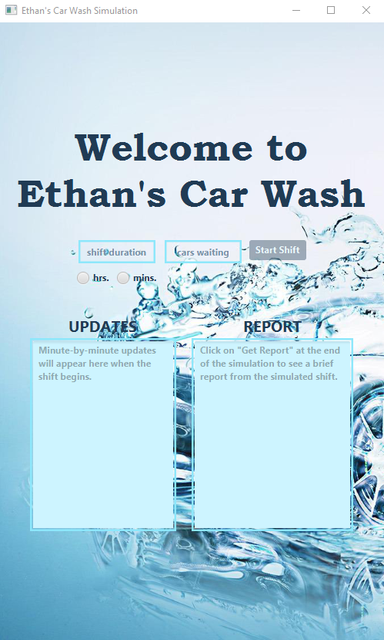

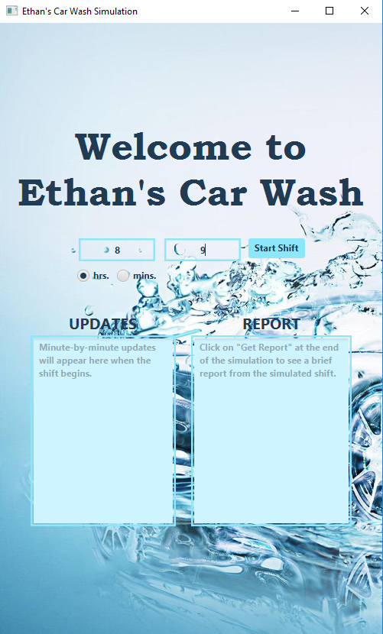

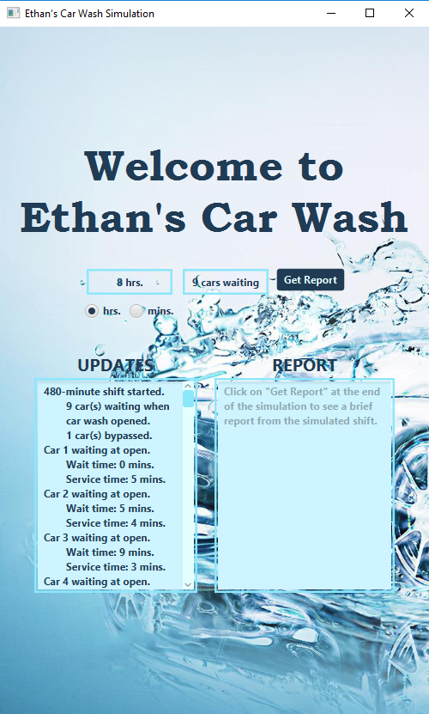

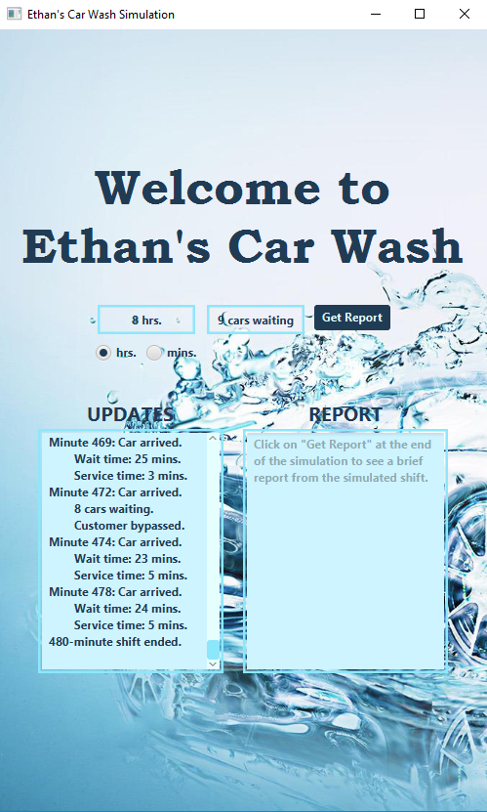

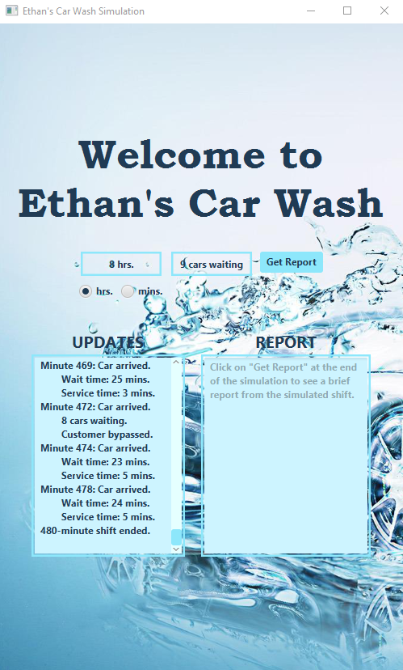

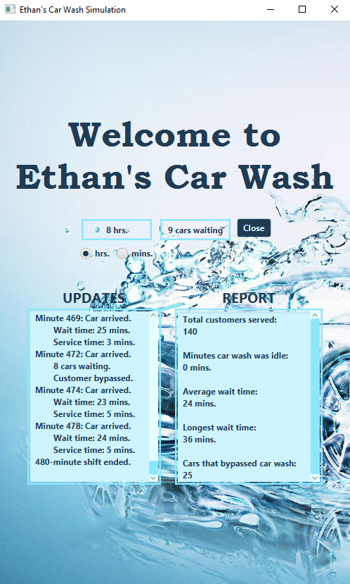

Brief Sample Run for a 4-hour shift, 2 cars waiting at open

